**Project Planning Phase**

**Project Planning Template (Product Backlog, Sprint Planning, Stories, Story points)**

|  |  |
| --- | --- |
| Date | 28 October 2022 |
| Team Leader | Reshma |
| Project Name | Project -IoT Enabled Smart farming Applications |
| Maximum Marks | 8 Marks |

**Product Backlog, Sprint Schedule, and Estimation (4 Marks)**

Use the below template to create product backlog and sprint schedule

|  |  |  |  |  |  |  |
| --- | --- | --- | --- | --- | --- | --- |
| **Sprint** | **Functional**  **Requirement (Epic)** | **User Story**  **Number** | **User Story / Task** | **Story Points** | **Priority** | **Team**  **Members** |
| Sprint-1 | Registration | USN-1 | As a user, I can register for the application by entering my Gmail, email then you can received the OTP or Verification Code. | 2 | High | M.Arun,  E.Naveen,  M.Karthik,  S.Reshma |
| Sprint-1 |  | USN-2 | As a user, I will receive confirmation Gmail or email once I have registered for the application. | 1 | High | M.Arun,  E.Naveen,  M.Karthik,  S.Reshma |
| Sprint-2 |  | USN-3 | As a user, I can register for the application through Gmail and phone number. | 2 | Low | M.Arun,  E.Naveen,  M.Karthik,  S.Reshma |
| Sprint-1 |  | USN-4 | As a user, I can register for the application through Gmail | 2 | Medium | M.Arun,  E.Naveen,  M.Karthik,  S.Reshma |
| Sprint-1 | Login | USN-5 | As a user, I can log into the application by entering email & password | 1 | High | M.Arun,  E.Naveen,  M.Karthik,  S.Reshma |

|  |  |  |  |  |  |  |
| --- | --- | --- | --- | --- | --- | --- |
| **Sprint** | **Functional**  **Requirement (Epic)** | **User Story**  **Number** | **User Story / Task** | **Story Points** | **Priority** | **Team**  **Members** |
|  | Dashboard | USN-6 | Once confirmation message received after login the system and Check Credentials Once check the credentials after go to the Manage modules. | 2 | High | M.Arun,  E.Naveen,  M.Karthik,  S.Reshma |
|  |  | USN-7 | In this manage modules described the below functions like Manage System Admins Manage Roles of User Manage User permission and etc.. | 2 | Medium | M.Arun,  E.Naveen,  M.Karthik,  S.Reshma |
|  | Logout | USN-8 | Then check Temperature, humidity and moisture after then logout or exist the application. | 1 | Medium | M.Arun,  E.Naveen,  M.Karthik,  S.Reshma |

**Project Tracker, Velocity & Burndown Chart: (4 Marks)**

|  |  |  |  |  |  |  |
| --- | --- | --- | --- | --- | --- | --- |
| **Sprint** | **Total Story Points** | **Duration** | **Sprint Start Date** | **Sprint End Date (Planned)** | **Story Points**  **Completed (as on**  **Planned End Date)** | **Sprint Release Date (Actual)** |
| Sprint-1 | 20 | 6 Days | 24 Oct 2022 | 29 Oct 2022 | 20 | 29 Oct 2022 |
| Sprint-2 | 20 | 6 Days | 31 Oct 2022 | 05 Nov 2022 | 35 | 31 Oct 2022 |
| Sprint-3 | 20 | 6 Days | 07 Nov 2022 | 12 Nov 2022 | 45 | 05 Nov 2022 |
| Sprint-4 | 20 | 6 Days | 14 Nov 2022 | 19 Nov 2022 | 50 | 07 Nov 2022 |

**Velocity:**

Imagine we have a 10-day sprint duration, and the velocity of the team is 20 (points per sprint). Let’s calculate the team’s average velocity (AV) per iteration unit (story points per day)

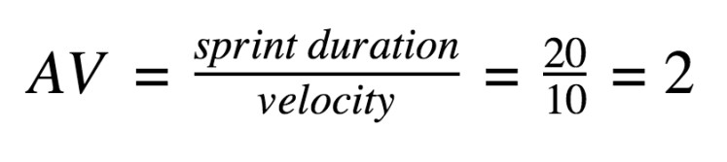

**Burndown Chart:**

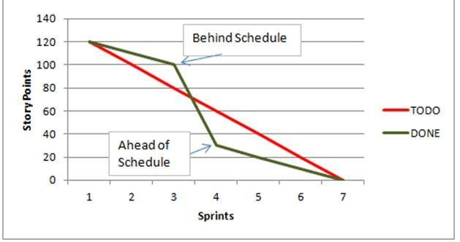

A burn down chart is a graphical representation of work left to do versus time. It is often used in agile software development methodologies such as Scrum. However, burn down charts can be applied to any project containing measurable progress over time.

**https://www.visual**

**-**

**paradigm.com/scrum/scrum**

**-**

**burndown**

**-**

**chart/**

**https://www.atlassian.com/agile/tutorials/burndown**

**-**

**charts**

**Reference:**

**https://www.atlassian.com/agile/project**

**-**

**management**

**https://www.atlassian.com/agile/tutorials/how**

**-**

**to**

**-**

**do**

**-**

**scrum**

**-**

**with**

**-**

**jira**

**-**

**software**

**https://www.atlassian.co**

**m/agile/tutorials/epics**

**https://www.atlassian.com/agile/tutorials/sprints**

**https://www.atlassian.com/agile/project**

**-**

**management/estimation**

**https://www.atlassian.com/agile/tutorials/bu**

**rndown**

**-**

**charts**